Maps Maps Maps
Much like cartography maps, there are a whole array of ways to visualise a system, journey, or flow in a map, from broad system landscapes to really specific micro journeys. Choosing the right type of map, and knowing how to start can be difficult, so here is a guide!

Experience Map

What it is
A map to represent the experience of an individual (could be a persona), over a period of time until a goal is achieved.

These maps tend to expand beyond a particular service or solution, and may even map how a goal is achieved in an area where a solution is to be innovated, to document current pain points/areas for new tools.

The focus is on the human experience, and may map actions, thoughts and feelings.

When to use it
For mapping experiences as is. Emotions and thoughts cannot be captures for something that doesn’t exist.

How to get started
With research. Observational, interviewing and analytics data can contribute to these maps.
Establish a timeline, with a trigger/starting point and an end point/goal, then fill in the bits in between

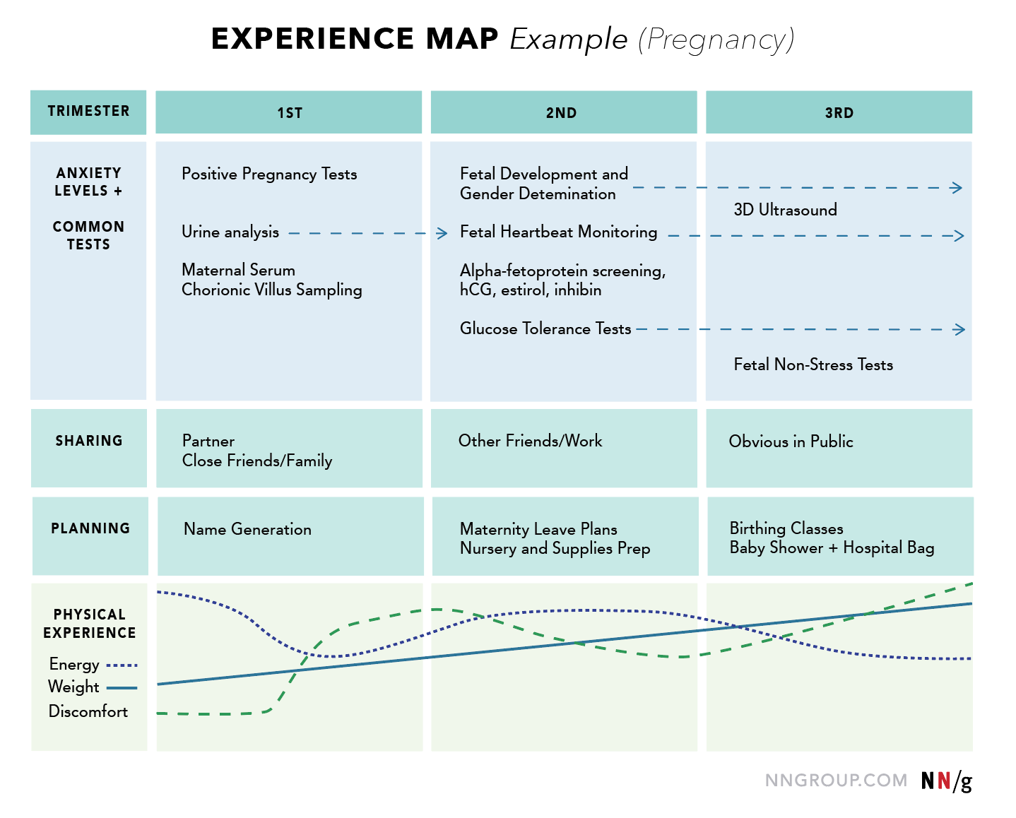Experience Map UX Mapping Cheat Sheet NN/g

Customer Journey Map

What it is
Mapping the interactions for a particular solution or product.
Ideally produced with customer research, however, other forms of customer input can work, including service desk tickets and complaints.

When to use it
When you need a tool for alignment and reference material for the future of a product.

How to get started
Collaboration with the product or solution team to determine the phases and touch-points, then fill out with customer input.
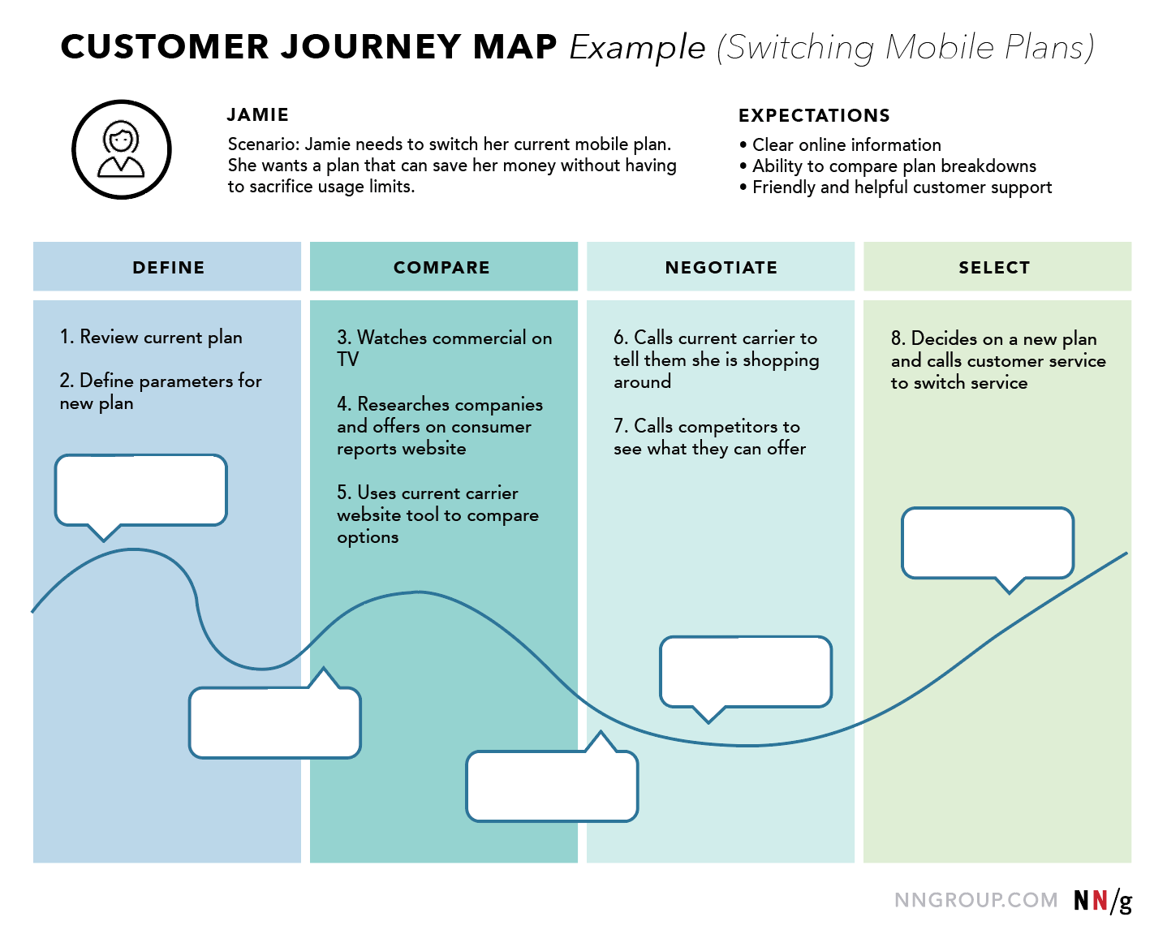Customer Journey Map UX Mapping Cheat Sheet NN/g

User Flow

What it is
A visual way of capturing task/goal walkthroughs of a system.
Can be as high or low fidelity as needed.

Determine a start point, and end point, then capture all the routes between those points.

When to use it
For an existing system to gain an understanding.
When designing the flow for a new system.

How to get started
Work with designers and system architects and work through decision points
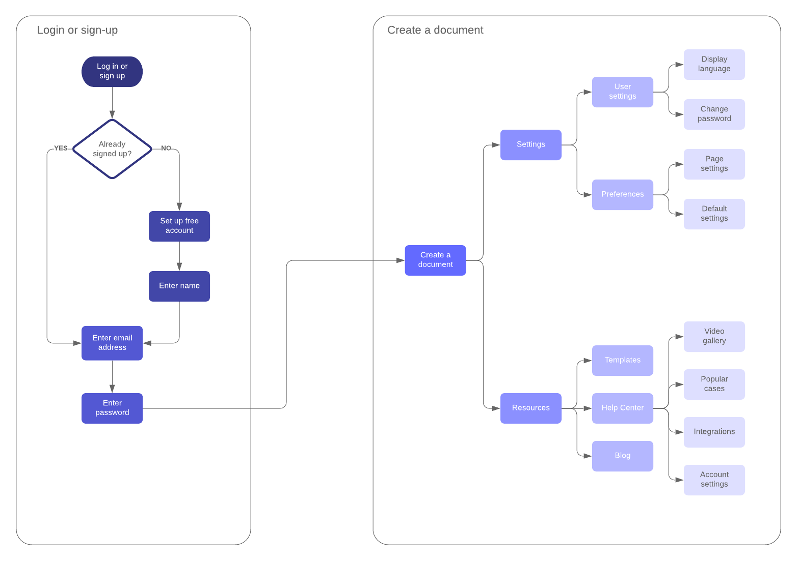user journey flow template
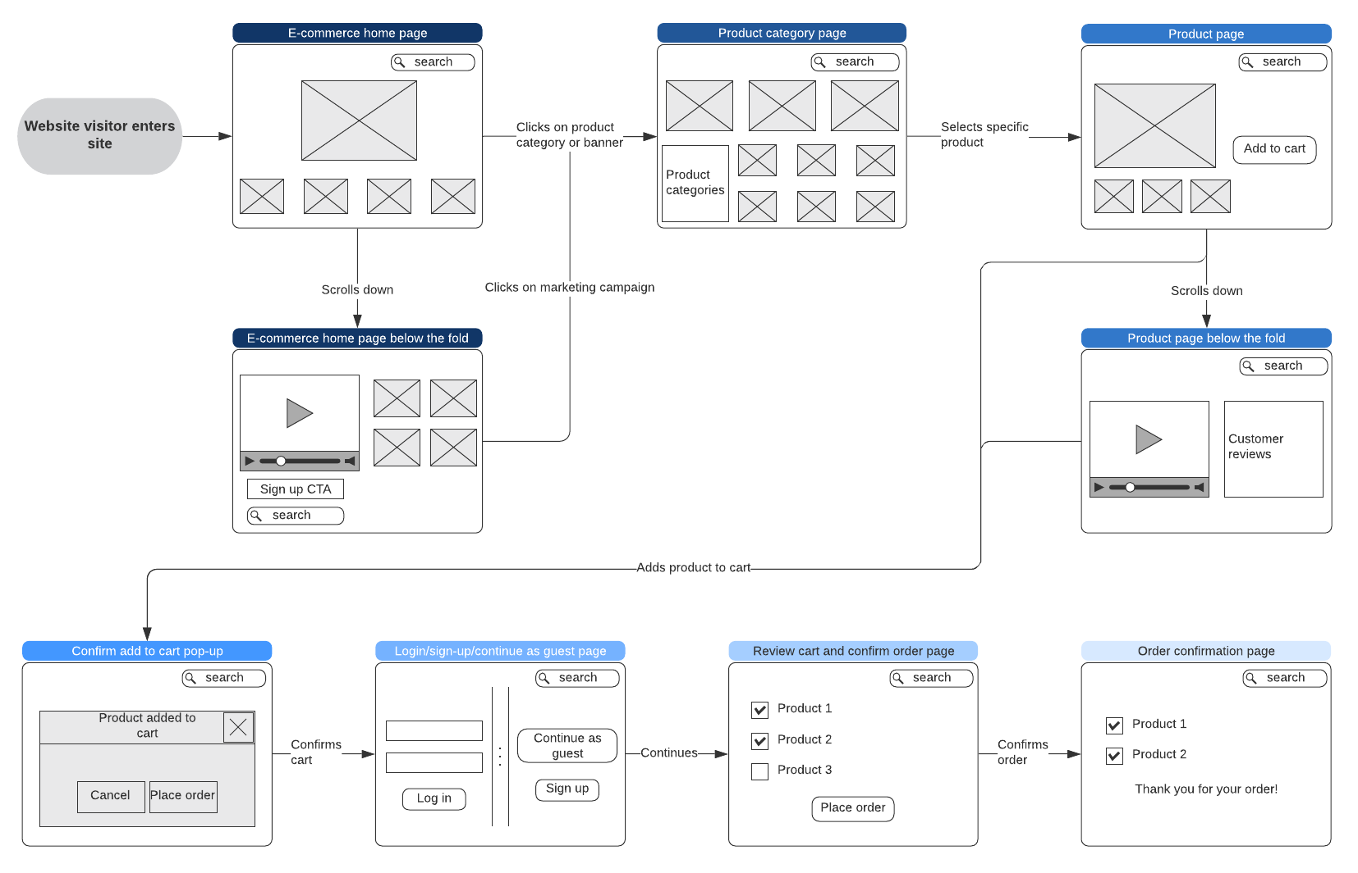e-commerce website user flow

Service Blueprint

What it is
Visualisation of the connections between customers/users, employees, and systems.
Helps understand gaps in cross-department offerings and identify areas of weakness or opportunity.

When to use it
Before making organisational changes
To align a number of teams and provide a reference point.

How to get started
Collaborate with stakeholders
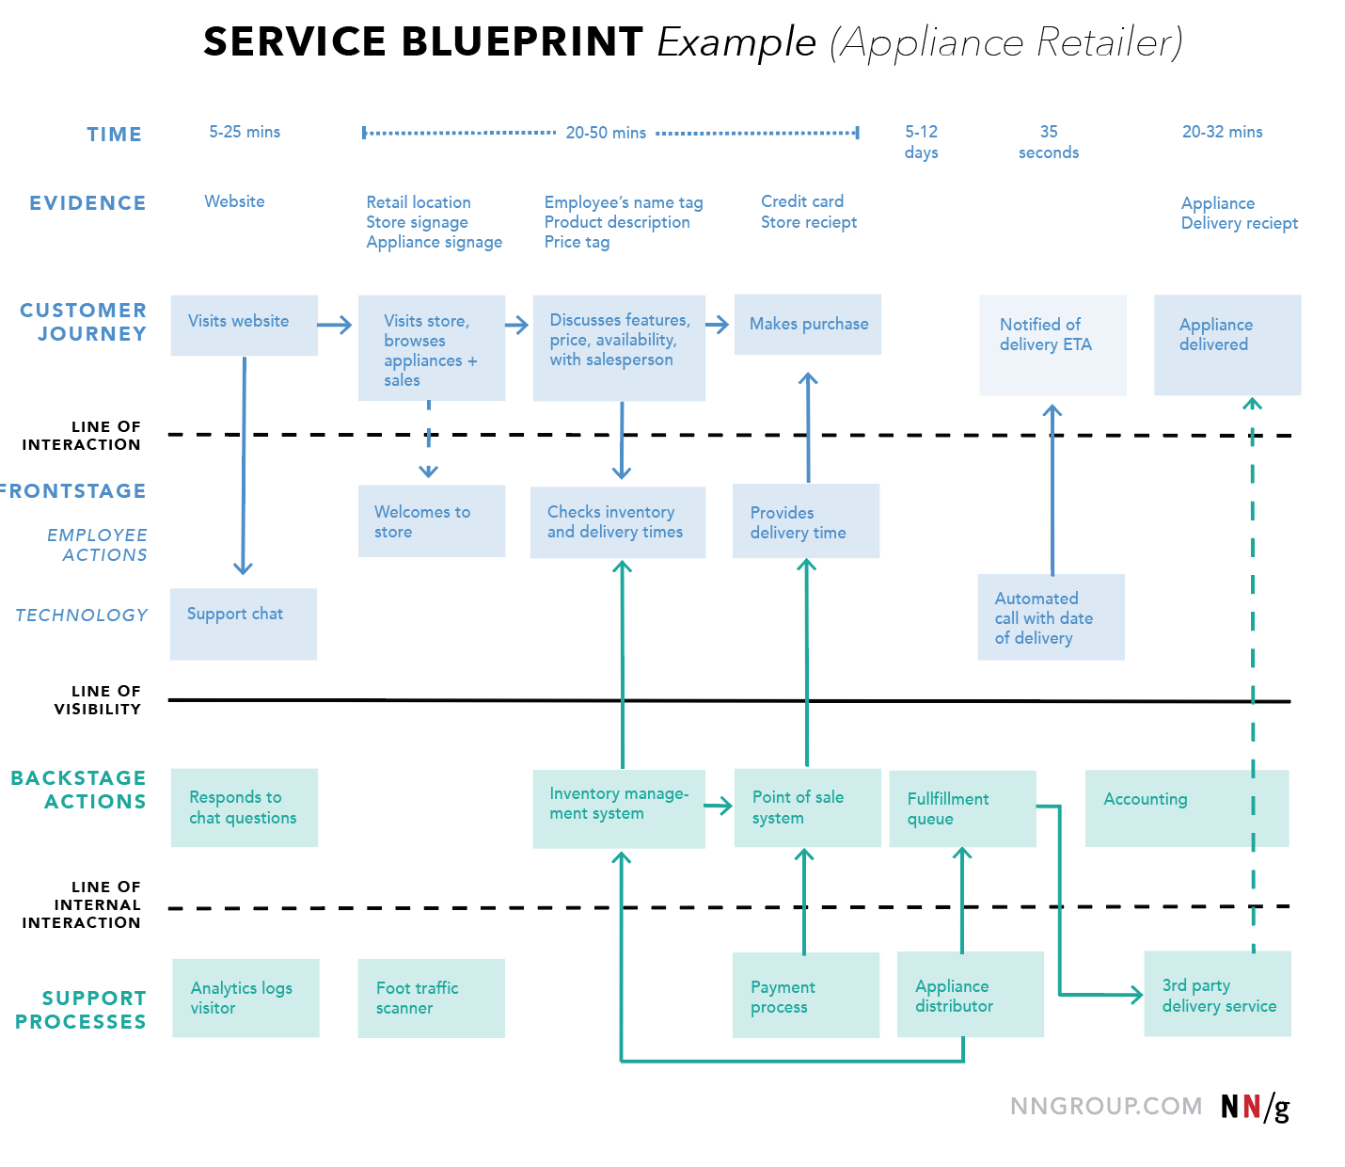Service Blueprint UX Mapping Cheat Sheet

Service Landscape

What it is
A visual representation of all the services and systems a user may come into contact with to achieve a goal.
Should be contributed to by a broad spectrum of stakeholders.

When to use it
When breaking organisational silos.

How to get started
Figure out what the user goal is, then bring together all the services a user may touch upon to achieve it.
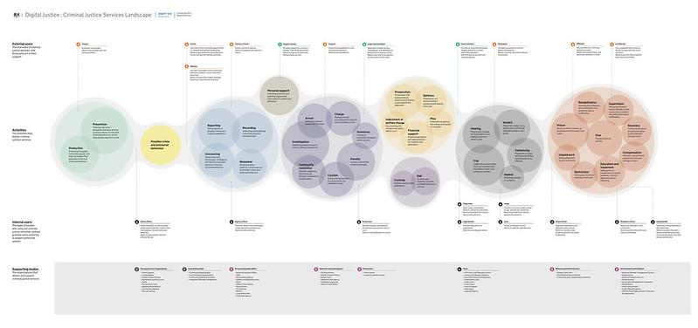

Micro vs Macro

What it is
Sometimes it’s possible to get caught up in over-mapping, if you haven’t determined the level of detail up front. Where a map is getting unwieldy, or sections may be done repeatedly, breaking it into ‘micro’ maps may be appropriate, which can then be fitted together for an overall view, or each ‘micro’ map can be simplified and put together for a ‘macro’ map

UML Diagrams

What it is
UML Diagrams covers a range of visualisation options that follow a standard format. Useful for communicating data structures with engineers.
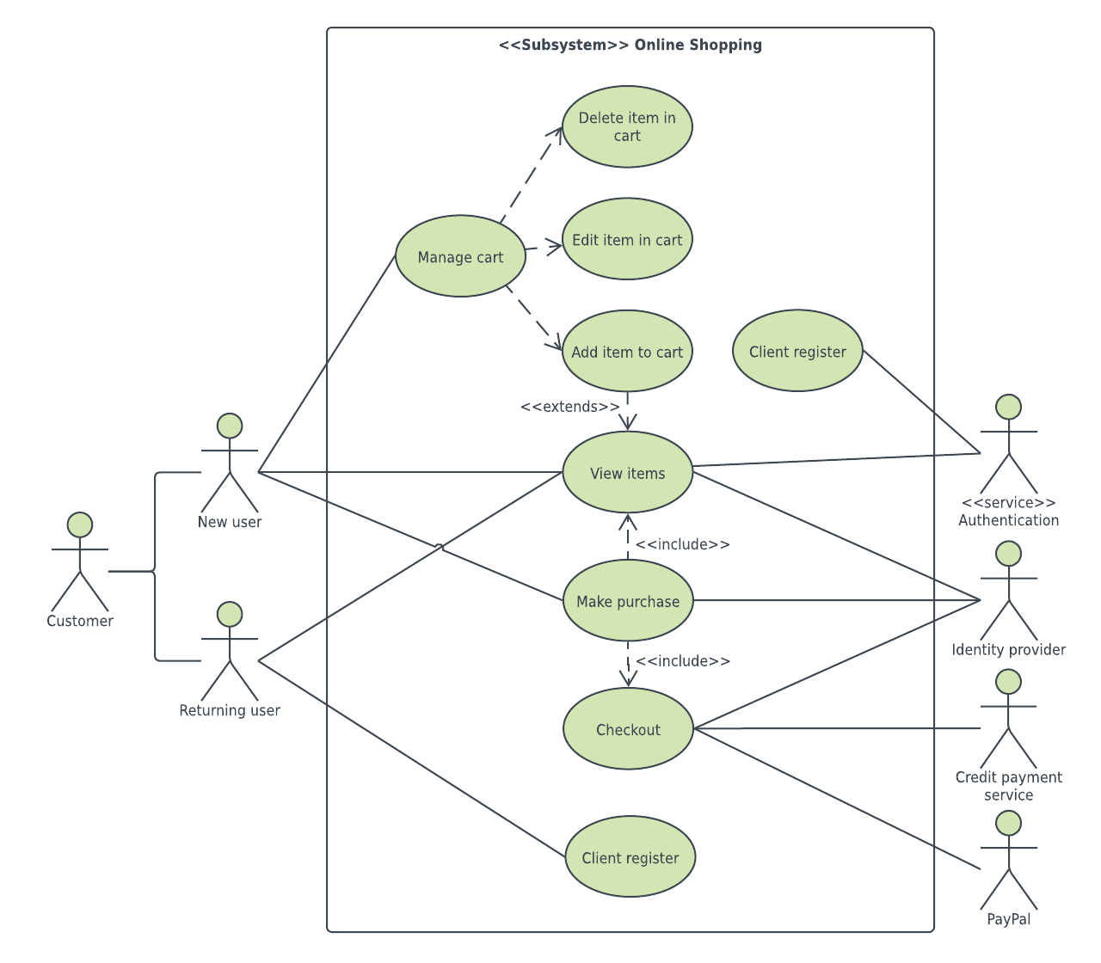online shopping use case diagram example
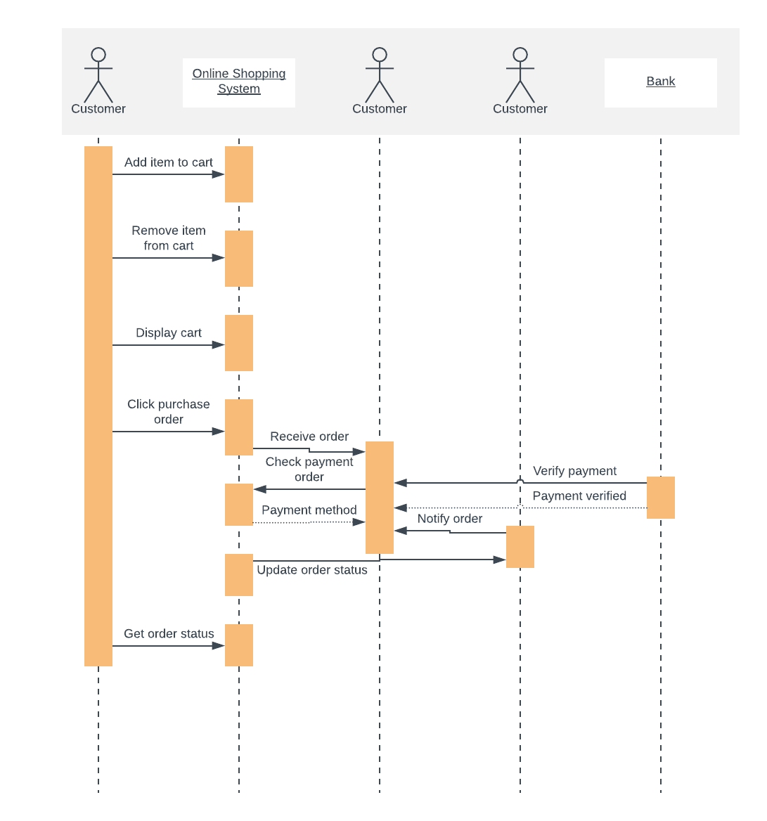online shopping UML sequence diagram template

Stakeholder Mapping

What it is
A visualisation of the relationships of stakeholders.
Use colour and size to represent importance.

When to use it
At the beginning of a project to capture who the users and stakeholder of a project may be

How to get started
Start with the immediate team and spread out from there
Why stakeholder maps can be an expert's best friend | EXPERTUNITY

Domain/Concept Modelling

What it is
A way to capture the variety of aspects and influences on a domain of interest

When to use it
To gain understanding of the area of interest.

How to get started
Interview some domain experts and start pulling out entities and relationships related to the area of interest
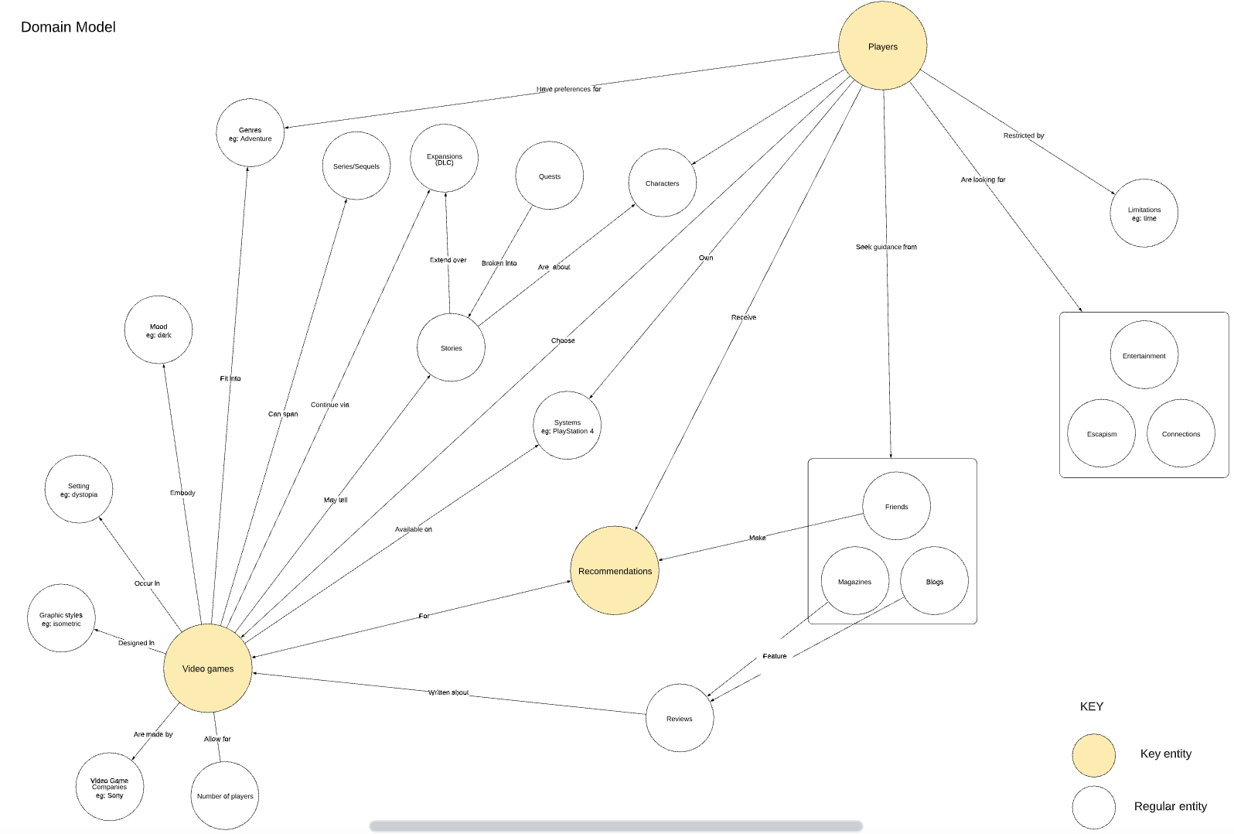

Resources
https://www.nngroup.com/articles/ux-mapping-cheat-sheet/
https://www.lucidchart.com/pages/what-is-UML-unified-modeling-language
https://uxdesign.cc/when-to-use-user-flows-guide-8b26ca9aa36a

